ME 635: Modelling and Simulation

Homework 2

Simulation models using Arena

09/19/2022

I pledge my honor that I have abided by the Stevens Honor System.

Submitted by,

Viral Panchal.

Q1.

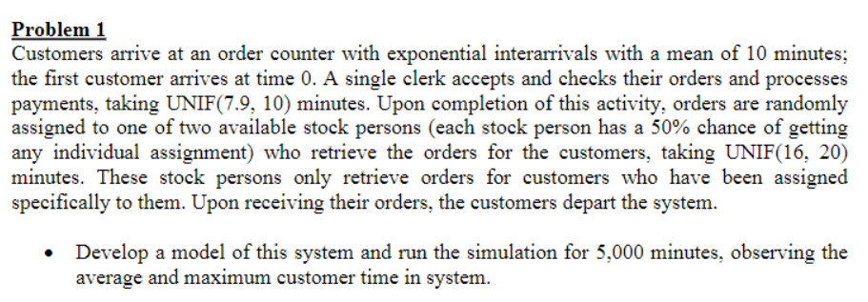

Model:

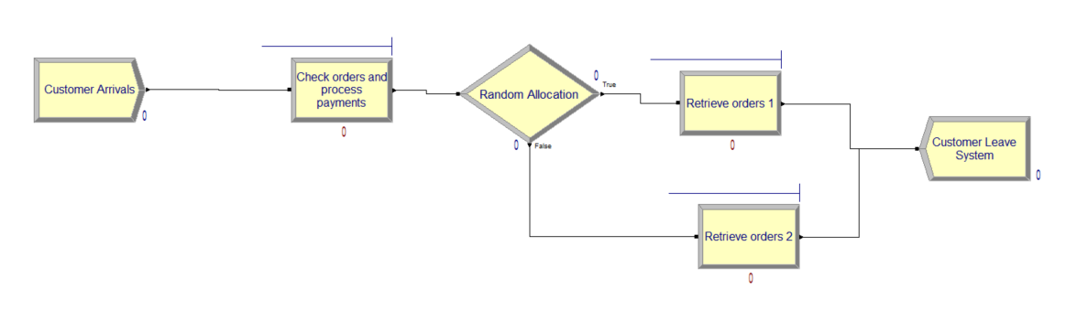

# [Q1_ViralPanchal_zip file](Q1.zip)

*(The zip file has the arena models and pdf report generated.)*

Results:

Average customer time is 1.6704 hours

Maximum customer time is 3.6293 hours

Q2.

Model:

# [Q2_ViralPanchal_zipfile](Q2.zip)

*( The zip file has the arena models and pdf report generated.)*

Result:

Number of good parts = 441

Number of inspected parts = 44

Number of scrapped parts = 4